Rudra Chinhara

Write a class TIME to store time in hours and minutes. Write a friend function to add two TIME objects.
Time
Github Link

CODE
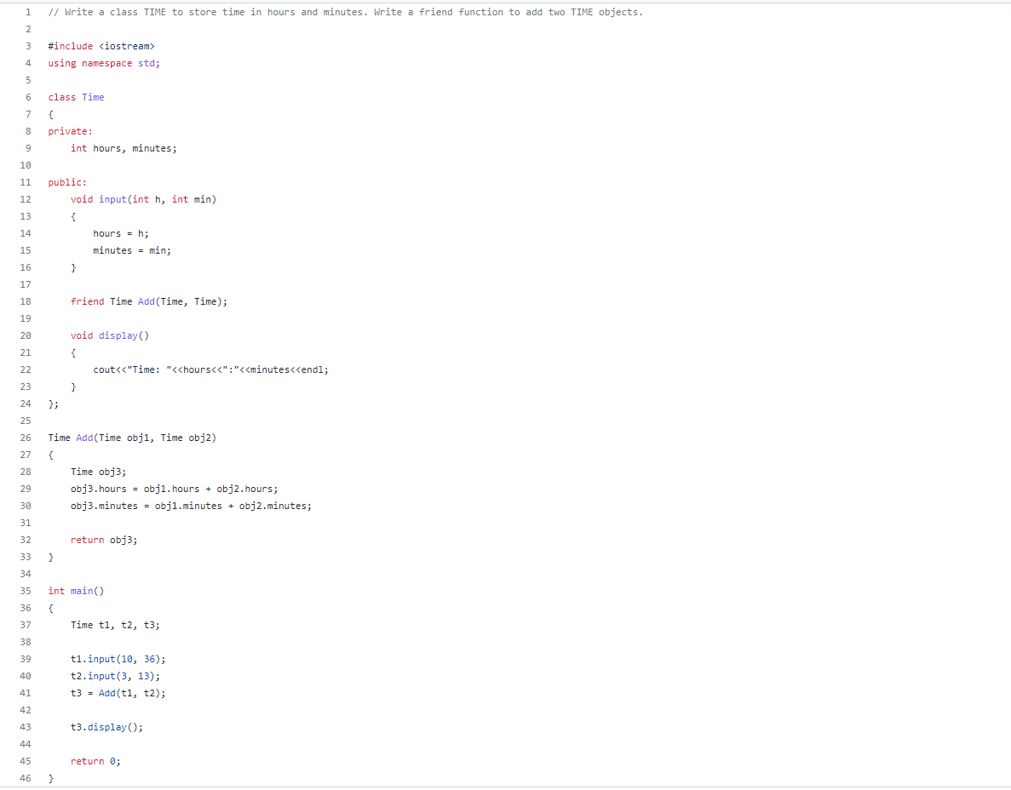
OUTPUT
